Created time.txt file using touch

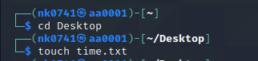

Created a write_time.sh file

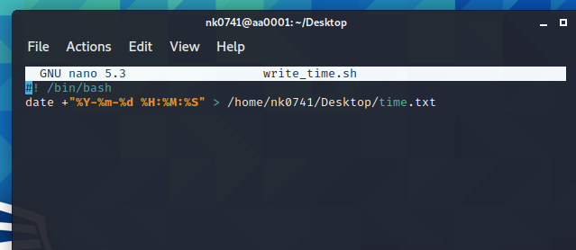

Created a service using the below command and entered the context. 

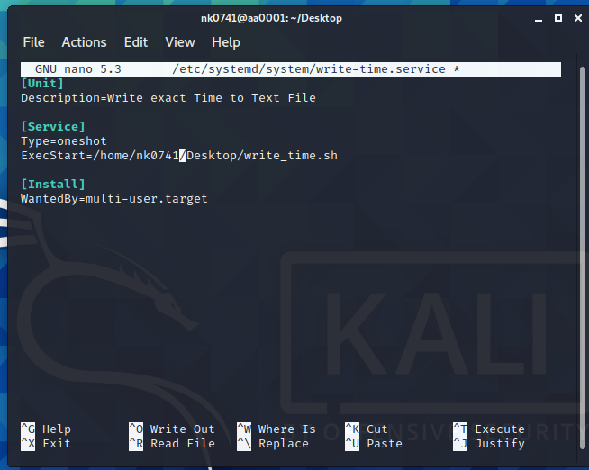

Created a timer file and written context. 

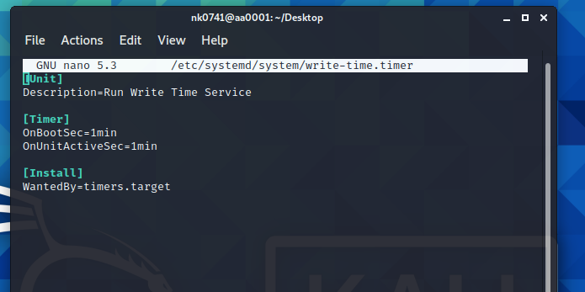

I have enabled the service by using below command. 

I have started the service by using start command. 

I have displayed the file which I have stored on desktop and it displays the time.

